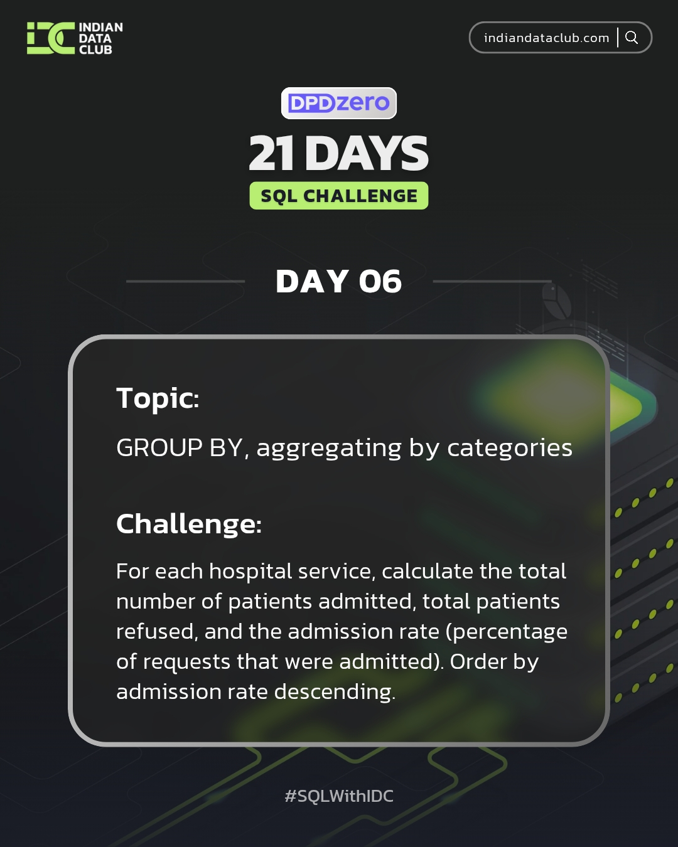

Day-6 SQL Challenge
Day-6 Challenge:
For each hospital service, calculate the total number of patients admitted, total patients refused, and the admission rate (percentage of requests that were admitted). Order by admission rate descending.
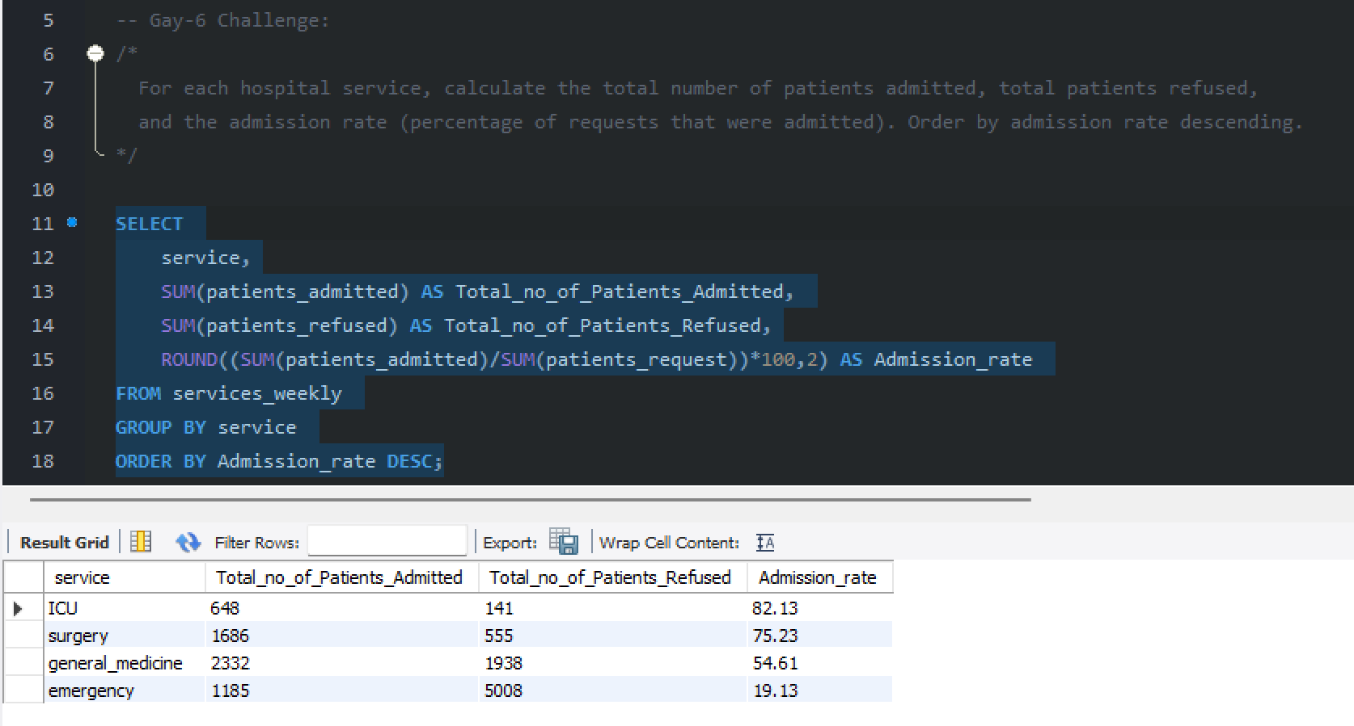

Practice Questions:
1. Count the number of patients by each service.
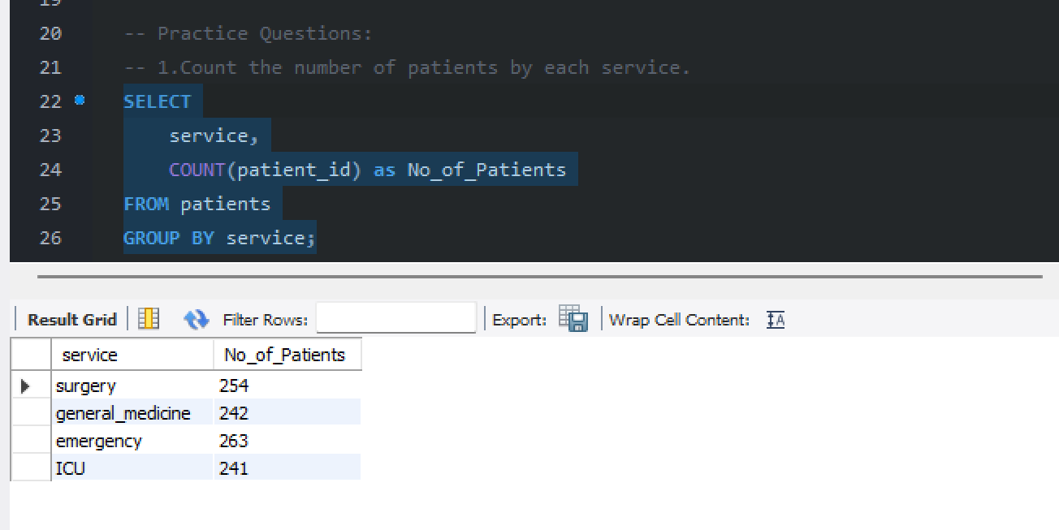

2. Calculate the average age of patients grouped by service.
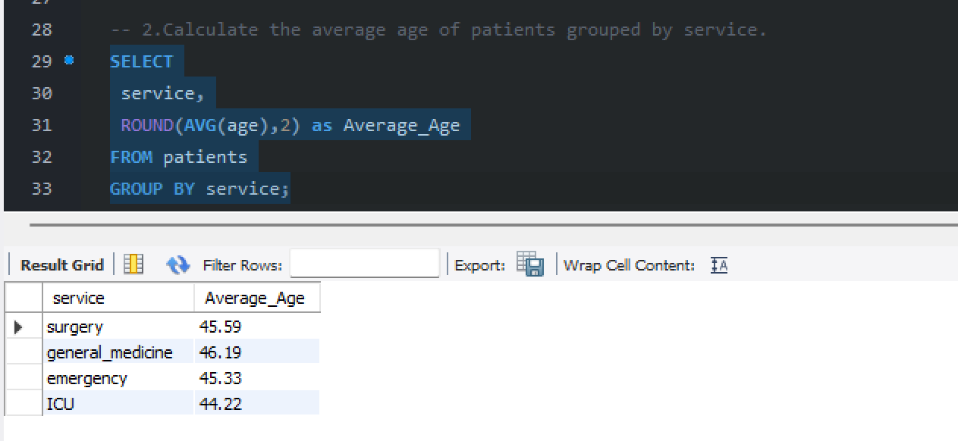

3. Find the total number of staff members per role.
